How Machine Learning is reshaping Price Optimization

[*Javier*](https://tryolabs.com/blog/authors/javier-couto/) Mon, Sep 24, 2018 in [**Machine Learning**](https://tryolabs.com/blog/categories/machine-learning/)

https://tryolabs.com/blog/price-optimization-machine-learning/

* [Machine Learning](https://tryolabs.com/blog/tags/machine-learning/)
* [Price Optimization](https://tryolabs.com/blog/tags/price-optimization/)
* [Retail](https://tryolabs.com/blog/tags/retail/)

The challenge of setting the right price

Setting the right price for a good or service is an old problem in economic theory. There are a vast amount of [pricing strategies](https://www.thebalancesmb.com/retail-pricing-strategies-2890279) that depend on the objective sought. One company may seek to maximize profitability on each unit sold or on the overall market share, while another company needs to access a new market or to protect an existing one. Moreover, different scenarios can coexist in the same company for different goods or customer segments.

In this blog post, we’ll present the problem of **price optimization for retail** – which has

of Machine Learning (ML) technology to build **effective pricing automation solutions**.

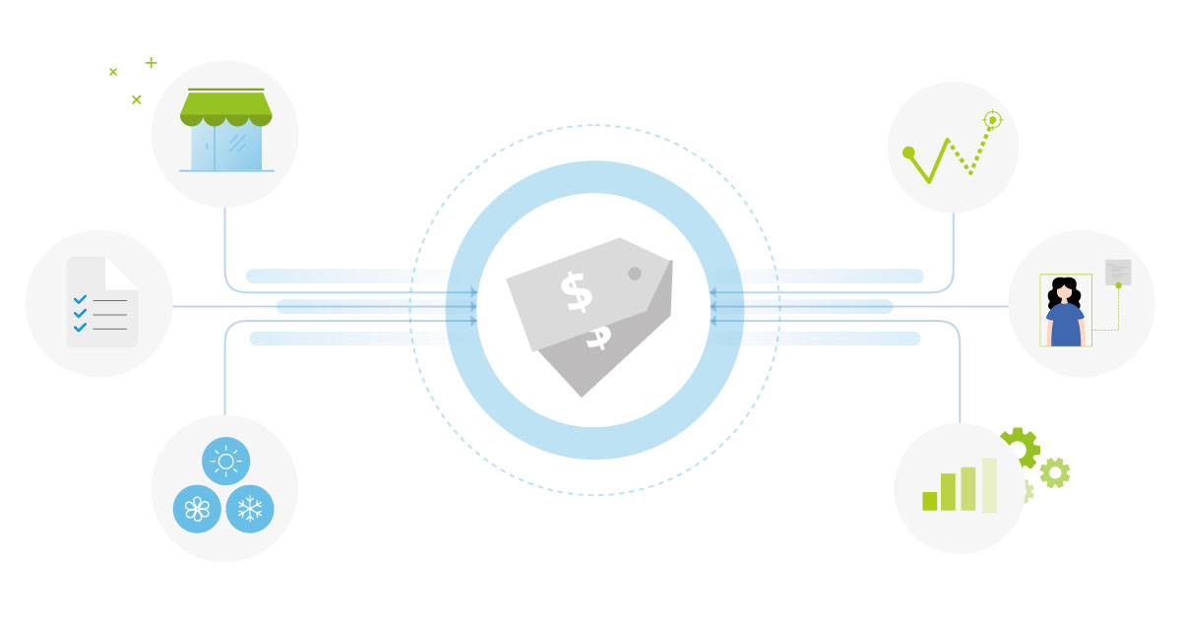

These are some of the **crucial questions that retailers recurrently face**:

* What price should we set if we want to make the sale in less than a week?
* What is the fair price of this product, given the current state of the market, the period of the year, the competition, or the fact that it is a rare product?

Given that in these days it is **very easy for a customer to compare prices** thanks to online catalogs, specialized search tools or collaborative platforms, retailers must pay close attention to several parameters when setting prices. Factors such as competition, market positioning, production costs, and distribution costs, play a key role for retailers in order to make the right move.

**ML can be of great help** in this case and have an **enormous impact on KPIs**. Its power lies in the fact that the developed **algorithms can learn patterns from data**, instead of being explicitly programmed. ML models can continuously integrate new information and detect emerging trends or a new demands.

The use of ML is a very attractive approach for retailers. Instead of using, for example, aggressive general markdowns (which is often a bad strategy), they can benefit from **predictive models** that allow them to determine the **best price for each product or service**.

What is price optimization?

Briefly, price optimization uses data analysis techniques to pursue **two main objectives**:

1. Understanding how customers will react to different pricing strategies for products and services.
2. Finding the best prices for a given company, considering its goals.

Pricing systems have evolved since the early 1970s until now, from applying very simple strategies, such as a standard markup to base cost, to being capable of predicting the demand of products or services and finding the best price to achieve the set KPI.

Price optimization techniques can help retailers **evaluate the potential impact of sales promotions** or **estimate the right price** for each product if they want to **sell it in a certain period of time**.

Current state-of-the-art techniques in price optimization allow retailers to **consider factors such as**:

* Competition
* Weather
* Season
* Operating costs
* Local demand
* Company objectives

to **determine**:

* The initial price
* The best price
* The discount price
* The promotional price

Using different kind and sources of data to find the prices that improve profits.

Price optimization vs dynamic pricing

It is important to differentiate price optimization from [dynamic](https://en.wikipedia.org/wiki/Dynamic_pricing) [pricing](https://www.business.com/articles/what-is-dynamic-pricing-and-how-does-it-affect-ecommerce/), given that these terms are sometimes used as synonyms. The main difference is that dynamic pricing is a particular [pricing strategy](https://en.wikipedia.org/wiki/Pricing_strategies), while price optimization can use any kind of pricing strategy to reach its goals. Despite having many advantages and being quite used, dynamic pricing has some disadvantages when used in an extreme way.

Simply put, using a **dynamic pricing strategy**, retailers can **dynamically alter the prices of their products based on current market demand**. In contrast, price optimization techniques consider many more factors to suggest a price or a price range for different scenarios (e.g. initial price, best price, discount price, etc.).

We all know and somehow accept because it seems reasonable, that the price of a hotel room or a plane ticket varies according to the season, the day of the week or the anticipation with which we booked. However, when prices change too fast – sometimes in the course of a few hours – some customers might have the feeling that prices are unfair or that the company is practicing [price gouging](https://en.wikipedia.org/wiki/Price_gouging). Dynamic pricing is, therefore, a strategy to be used with caution.

What Machine Learning can do for retail price optimization

The pricing strategies used in the retail world have some peculiarities. For example, retailers can determine the prices of their items by accepting the price suggested by the manufacturer (commonly known as [MSRP](https://en.wikipedia.org/wiki/List_price)). This is particularly true in the case of mainstream products. Another simple strategy is [keystone](https://www.thebalancesmb.com/keystone-pricing-in-retail-2890192), which consists in defining the sale price as the double of the wholesale price or cost of the product.

While these and other strategies are widely used, **ML enables retailers to develop more complex strategies that work far better to achieve their KPIs**. ML techniques can be used it in many ways to optimize prices. Let’s have a look at a typical scenario.

A typical scenario

Imagine an online or brick-and-mortar retailer who wants to estimate the best prices for new products for the next season. The competition is hard, so their prices and promotions need to be taken into consideration. Therefore, the retailer adopts a widely used strategy: [competitive pricing](https://www.investopedia.com/terms/c/competitive-pricing.asp). Simply put, this strategy defines the price of a product or service based on the prices of the competition.

Let’s see the steps needed to develop a ML solution for this use case.

Process of defining prices in retail with price optimization using Machine Learning.

1. Gather input data

First of all, we need data. To train Machine Learning models, it is necessary to have different kinds of information:

* **Transactional**: a sales history that includes the list of the products purchased and, eventually, the customers who purchased them.
* **Description of the products**: a catalog with relevant information about each product such as category, size, brand, style, color, photos and manufacturing or purchase cost.
* Data on **past promotions** and past marketing campaigns.
* **Customer Reviews**: reviews and feedback given by customers about the products.
* Data on the **competition**: prices applied to identical or similar products.
* **Inventory and supply data**.
* In the case of physical stores: information about their **geographical location** and that of the competitors.

Start storing and structuring your data for price optimization today! Here are [5 actionable steps you can take to get your data ready for Machine Learning](https://tryolabs.com/blog/2019/03/27/data-preparation-price-optimization-machine-learning/).

Depending on the set KPIs and the way of modeling the solution, some of this data may not be necessary. For example, if there is little or no information about customers, which is sometimes the case for brick-and-mortar retailers, the model can nonetheless be trained.

In contrast, information about the competition is crucial for a competitive pricing strategy. In many cases, it is even possible to connect via APIs to this information or monitor it online.

2. Define goals and constraints

The next step is to define the strategic goals and constraints.

Retailers may pursue a unique, clear **objective** of profit maximization. However, they may also be interested in customer loyalty (e.g. increasing the net promoter score or the conversion rate) or in attracting a new segment (e.g. young people).

**Restrictions** may be of legal nature (e.g. if some type of control of sale prices is carried out), they may have to do with the reputation of the company (e.g. fearing a bad image for applying favorable prices only to a certain segment of customers) or be related to physical aspects such as the capacity of a store or the average time of supply.

Each particular scenario will impact the way the problem is modeled. It is possible, and usually very interesting, to test different scenarios for the same retailer, which implies using different models.

3. Modeling and training

In this step, the data previously gathered is used to train the ML models. There is a wide variety of models that can be used in price optimization. Historically, [Generalized Linear Models (GLMs)](https://en.wikipedia.org/wiki/Generalized_linear_model) have been used (in particular, [logistic regression](https://en.wikipedia.org/wiki/Logistic_regression). However, for a few years, more complex and powerful methods have been developed. For instance, depending on the volume of data available, it could be possible to use [Deep Learning](https://en.wikipedia.org/wiki/Deep_learning) methods.

In this case, in which we are dealing with new products for the next season, there is an additional difficulty since there is no previous product data. The interesting thing is that the ML models will know how to find similar products and be effective despite not having specific prior data. The same happens in the case of retailers that sell rare or exotic products.

4. Execute and adjust prices

Once the model is trained, **prices can be estimated for the new products**. Depending on the modeling, the estimate may be an exact price or a range. The prices obtained by the model can be subsequently adjusted manually by the retailer.

More opportunities of using Machine Learning for price optimization

Machine Learning can be used for other tasks related to pricing in retail. For example, given a new product, [clustering algorithm](https://en.wikipedia.org/wiki/Cluster_analysis) can quickly associate it with similar products to obtain a **probable price segment**. Another compelling possibility is to jointly **predict prices and demands for items that were never sold**.

More generally, ML can be a tremendous tool for **insights**:

* In what way is the sale of pants impacted when shirts’ prices are drastically cut?
* When efforts are made to sell more pens, are the related products, such as ink, notebooks or work agendas, impacted?
* Are customers who buy a certain computer more or less likely to buy monitors the following month?
* Are inactive clients in the last year sensitive to a promotion campaign?

These are just some examples of the questions that ML models can help answer.

Advantages of price optimization with Machine Learning

In addition to automation and speed, there are several advantages to using ML to optimize prices.

First, ML models can consider a **huge number of products** and **optimize prices globally**. The number and nature of parameters and their multiple sources and channels allow them to make decisions using fine criteria. This is a daunting task if retailers try to do it manually, or even using basic software.

For example, it is known that changing the price of a product often impacts the sales of other products in ways that are very hard to predict for a human. In most cases, the **accuracy** of a ML solution will be significantly higher than that of a human. In addition, retailers can modify the KPI and immediately see how the models recalculate prices for the new goals.

Second, by analyzing a large amount of past and current data, a ML can **anticipate trends early enough**. This is a key issue that allows retailers to make appropriate decisions to adjust prices.

Finally, in the case of a competitive pricing strategy, ML solutions can **continuously crawl the web and social media to gather valuable information** about prices of competitors for the same or similar products, what customers say about products and competitors, considering hot deals, as well as the price history over the last number of days or weeks.

A system that can learn most of what is happening in the market allows retailers to have more information than their competitors in order to make better decisions.

Online vs brick-and-mortar retailers

While it may seem more natural to apply ML in the case of online retailers, brick-and-mortar retailers can perfectly take advantage from this technology. For this type of retailers there are restrictions of physical order, which can be integrated into the models.

For example, it is possible to jointly optimize the sale price, the way in which the products are displayed, the place they occupy on the shelves and their location in the store.

Variables such as the dimensions of the product or the distance from the entrance of the store to the shelves play an important role in how the problem is modeled. This is not a problem of optimizing the space on the shelves, which can also be addressed with ML (see [The Guide to Retail Innovations Using Machine Learning](https://tryolabs.com/resources/retail-innovations-machine-learning/) for more information), but of building a model that captures the way in which the disposition of the products in the store influences the demand.

Companies using Machine Learning for price optimization

Price optimization has been used, with significant success, in industries such as hospitality, airline, car rental, and online retail. In some cases, it is more about dynamic prices than price optimization, and we saw above that these terms are sometimes confused.

One of the first success stories occurred in the early 2000s, when [Hilton Hotels Corp](http://www.businesstravelnews.com/More-News/Hotel-Rates-Go-Dynamic-Hilton-Intercontinental-End-Fixed-Pricing) and [InterContinental Hotels Group](http://www.businesstravelnews.com/Strategic-Sourcing/IHG-Doubles-Down-On-Dynamic-Pricing-Push) decided to eliminate fixed rates in favor of a fluid scheme, including dynamic pricing strategies. In those years the prices of the rooms were modified once or twice a day. The current computational power allows prices to change practically in real time.

The hotel industry continues to employ dynamic pricing strategies, based entirely on ML. Currently, Airbnb proposes a [dynamic price tool](https://learnairbnb.com/airbnb-supply-demand-dynamic-airbnb-pricing/) that recommends prices to its hosts, considering parameters such as seasonality, the day of the week or special events, and also more sophisticated factors such as photos of the property to be rented or the prices applied in the neighborhood. Other companies such as eBay and Uber have adopted similar approaches.

In the retail world, the most popular examples have been in e-commerce, but brick-and-mortar retailers have not been left behind. Although it is difficult to know precisely all the retail companies using ML to optimize their prices and operating processes, there are nevertheless some known success stories.

Companies like Ralph Lauren and Michael Kors use ML to [offer fewer markdowns and better manage their inventory](https://www.businesslive.co.za/bd/companies/2017-12-08-to-stock-or-not-to-stock--that-is-the-question-michael-kors-and-ralph-lauren-are-asking/), seeking to increase profit margins, even at the risk of losing a little revenue. Another well-known case is that of Zara, which uses ML to [minimize promotions and adapt quickly to the changing trends](http://houseofbots.com/news-detail/3173-1-zara:-leveraging-ai,-big-data-and-analytics). There are [many other success stories](https://ixtenso.com/en/story/31676-retail-replenishment-price-optimization-machine-learning-solutions-for-retail.html), such as Morrisons –one of the largest supermarket chains in the United Kingdom–, bonprix –an international fashion company based in Germany– or Monoprice –an American B2B and B2C electronics retailer–, among others. While there is no information available on the exact modeling of the problems, it is known that these companies are taking advantage of the power of ML to increase their revenues and improve operations.

Final thoughts

Pricing is a critical predictor of profitability that is very often hard or impossible to manage without technological support. Retailers face thin margins and competitive pressures every day and sometimes must make decisions fast.

Price optimization helps retailers **understand how customers will react to different price strategies** for products and services, and set the best prices. Machine Learning models can take key pricing variables into account (e.g. purchase histories, season, inventory, competitors’ pricing), to **find the best prices**, even for vast catalogs of products or services, that can achieve the set KPIs.

These **models don’t have to be programmed. They learn patterns from data** and are capable of adapting themselves to new data. They allow retailers to quickly test different hypotheses and make the best decision.

What is probably most important to keep in mind is that the [use of Machine Learning in the retail world keeps widening](https://tryolabs.com/resources/retail-innovations-machine-learning/), and all signs point to the fact that this trend will continue in the coming years.

Here at [Tryolabs](https://tryolabs.com/), we specialize in Machine Learning solutions for retail companies. Since 2010, we have been working with several retailers, which let us better understand the opportunities, challenges and available solutions within the industry. The massive amounts of data available to retail companies allow us to conceptualize & build custom Machine Learning systems to improve companies’ KPIs.

I hope you enjoyed the post. Please don’t hesitate to comment below or drop us a line if you have any questions or comments.